
Secondary school N 1 of Atbasar town of the Department of Education of Atbasar region
ENGLISH

FOR KAZAKHSTAN
WORKBOOK &
GRAMMAR BOOK

English teacher
Nurmanova Aliya Nurlanovna

Atbasar 2019
1а
Vocabulary
Rooms, furniture, appliances
- Wright the words under the words headings
Bedside cabinet, bathroom, lamp, wardrobe, cooker, living room, table, hall, desk, kitchen, chair, bedroom, fridge.
Rooms | Furniture | Appliances
……………………………  ……………………………..  ………………………………  ………………………………  ………………………………  ……………………………….. | ………………………………  ………………………..  …………………………  …………………………  …………………………  …………………………. | ………………………..  ………………………..  …………………………  …………………………  …………………………  …………………………..

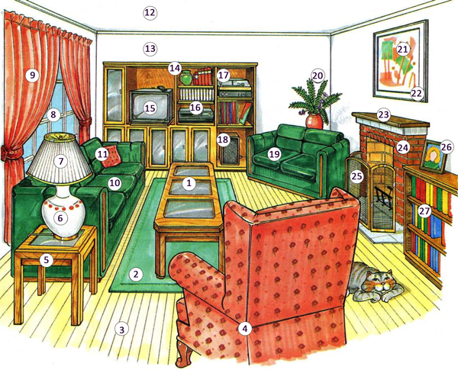
- Label the word
For ex. Number one is a table
……………………………….
……………………………….
………………………………
1a
- Complete the sentences using there is/there are
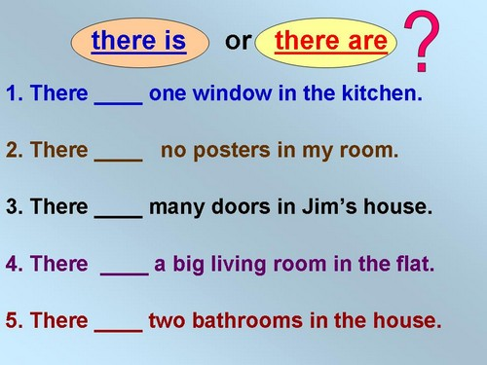

- Look at the picture. Use from the list to write what
there is/isn’t or are/aren’t

fridge, mirror, painting, sofa, armchair, stairs, curtains, bookcase, cushion, carpet, cupboards, pillow

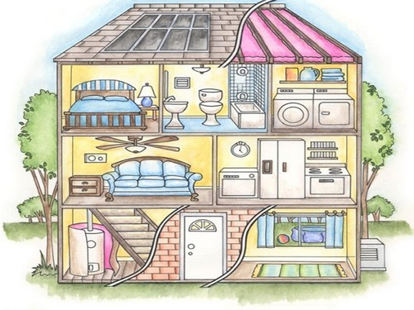

- There is a lamp.
- …………………......................................
- …………………………………………..
- …………………………………………..
- …………………………………………..
- …………………………………………..
- …………………………………………..
- ……………………………………………..
- ……………………………………………..
- …………………………………………
- …………………………………………
- …………………………………………

- Write what furniture/appliances there is/are in your kitchen.
……………………………………………………………………………………………………………………………………………………………………………………………………………………………………………………………………………………………………………………………………………………………………………………………………………………………………………………………………………………………………………………………………………………………………….

- Match the words to form phrases.
Living furniture
Kitchen room
Bedroom floor
Bedside cabinet
1a
Use of English
There is/there are

- Fill in there is, there isn’t, there are, there aren’t
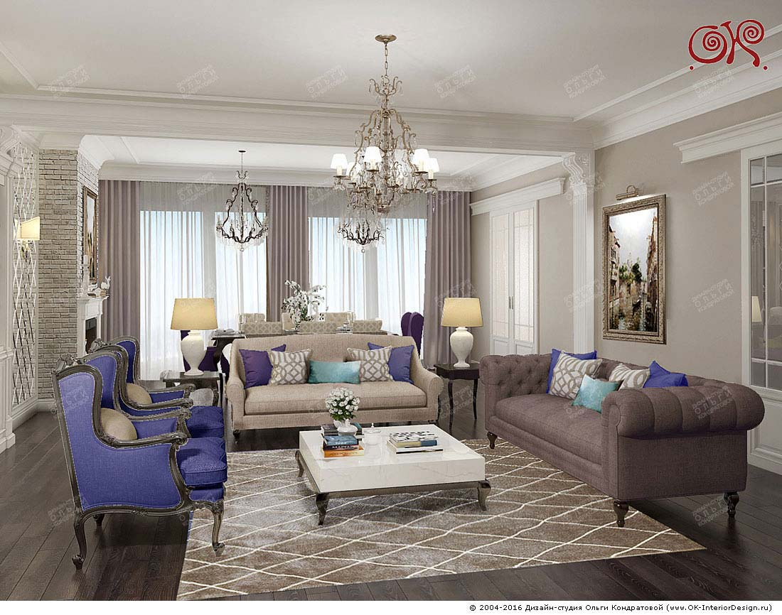

1……………………….. ……………some lamps.
2………………………………………some armchairs.
3……………………………………..some cushions
4……………...................... a pinting.
5…………………………..a desk.
6……………………………………some sofas.
7…………………………….a carpet.
8…………………………… a flower.

1a
- Look at the picture again. Complete the questions. Answer them.

1…………..............any cushions? Yes,………………..
2……………….. a painting? Yes,………………………
3………………. a desk? Yes,…………………………..
4………………….. a sofa? No,………………………..
5………………….. some carpets? No,………………….

- Describe your room and complete sentences
1…………………………..a bed in my room.
2…………………………on my wall.
3………………… a computer in my bedroom.
4………………..a wardrobe in my bedroom.
5………………….two chairs in my room.
6…………………..one window in my room.
7…………………..a bookcase in my room.
8……………………a lamp in my bedroom

Preposition of places

- Circle the correct prepositions
- There is a yard in / in front of the house.
- There is a painting in on / behind the wall.
- My kitchen is under / next to the bathroom.
- The dog is between / under the table.
- The garden in / behind the house.
- a
5. What is there in your kitchen?
Write sentences.
There is a fridge in my kitchen.
…………………………………………………………………………………………………………………………………………………………………………………………………………………………………………………………………………………………………………………………………………………………………………………………………………………………

A/An – Some – Any
- Complete with a/an, some or any
- A: Are there ……… trees in the yard?
B: No, there aren’t………………….

- A: Have you got a pencil?
B: I haven’t got one in my bag, but there are
…………… on my desk.

- A: Are there……….cushions on your sofa?
B: Yes, there are……………..

- A: Is there ….. orange on the table?
B: No, there ……………………..

- A: Are there………. apple in the fridge?
B: Yes, there is …….apple in the fridge.
1a
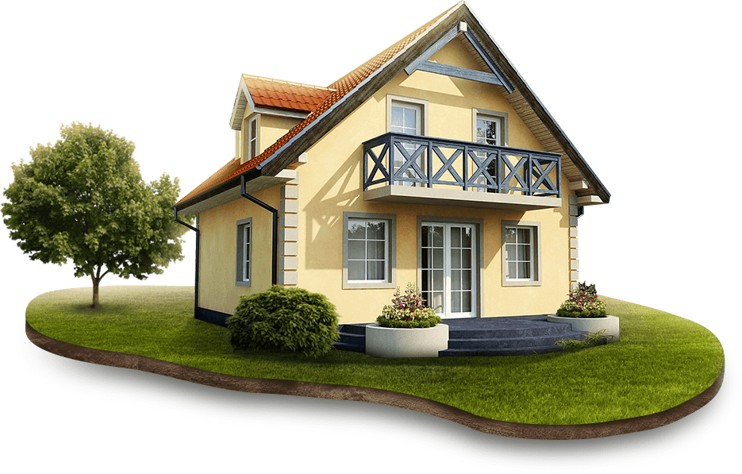
Reading 1. Read the text.
We have a nice house. This is
a picture of our house. You
can see it is not very big.
There are four rooms in
our house: a living-
room, a dining-room
and two bedrooms, and
a kitchen. The door of the house is shut. You can see three large windows of the living-room. The windows are open. You cannot see the kitchen windows. The kitchen is behind the living-room.
In front of the house there is a small garden with flowers in it. There is a garden behind the house too. You can see flowers and trees in the garden.

Answer the questions.
- How many rooms in this hose?
…………………………………………………………..
- How many floors are there?
……………………………………………………………
- Is kitchen behind the living room?
…………………………………………………………….
- Are there flowers and trees in the garden?
……………………………………………………………..
- Is the garden behind the hose?
……………………………………………………………..
2.
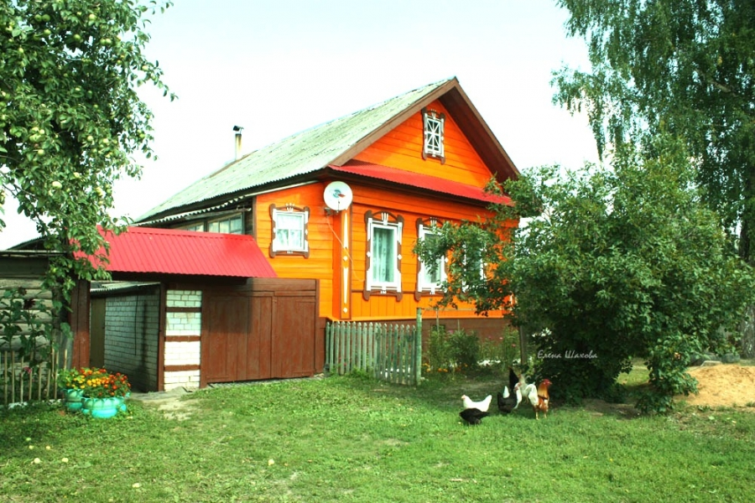
Mary's House
I have a friend. Her name is Mary. Mary's house is in a village. The name of the village is Green Meadow. There are many new houses in this village. There are many trees in the streets of the village and in the gardens.
Mary's house is not very big, it has four rooms and a kitchen. Two of the rooms are large. They are the living-room and the dining-room. There are two bedrooms in Mary's house. One of the bedrooms is Mary's room. Her room is not large. It has one window.
In front of Mary's house there is a small garden with flowers in it. There is a kitchen-garden behind the house. You can see many apple-trees in the garden. Mary's house is very nice.
True or False
- Friend’s name is Mary _________
- The house is in the city _________
- The name of the village is Red Meadow __________
- There aren’t many trees in the streets ___________
- Mary’s house is big _____________

2а
Vocabulary
Look at Bill’s family tree and choose the correct words
Sam
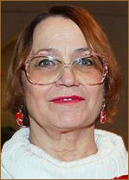 Ann

 Bill
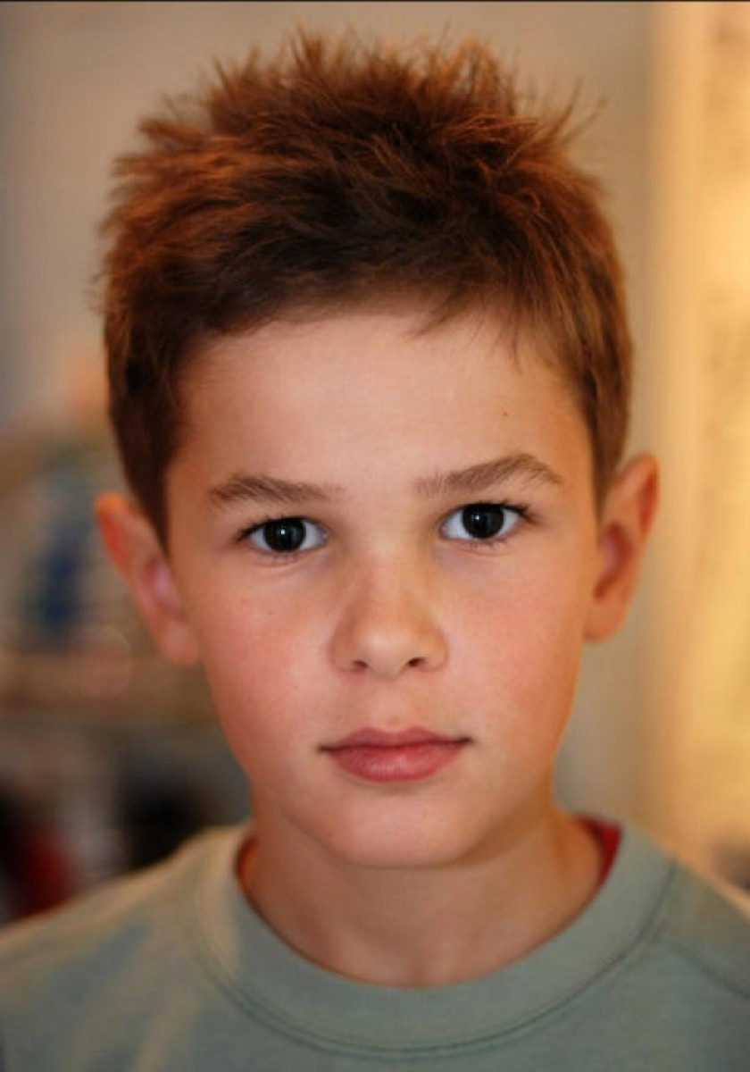Chris
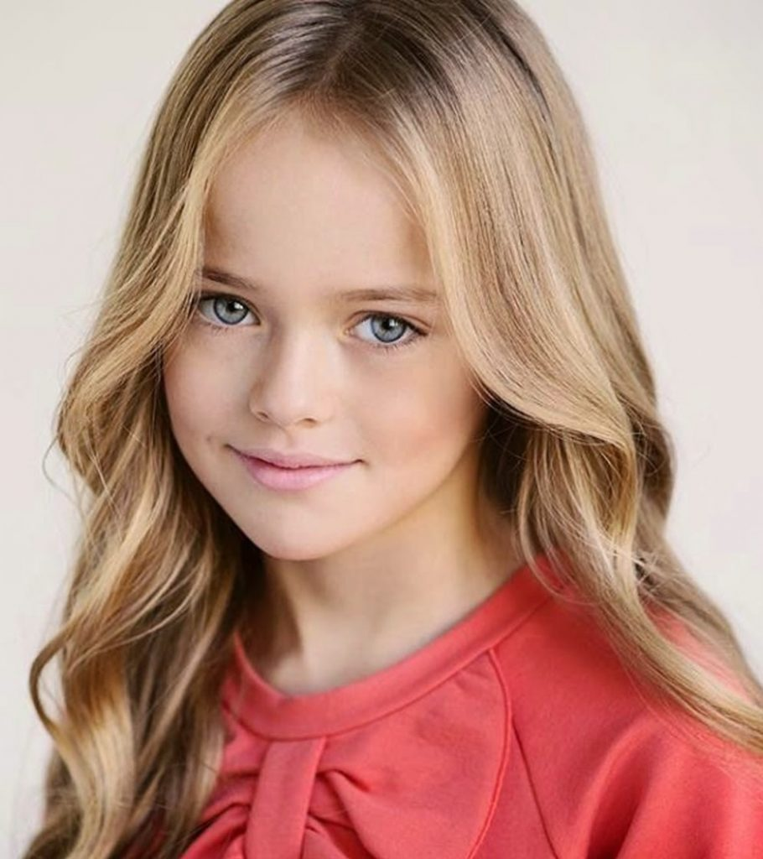Stella
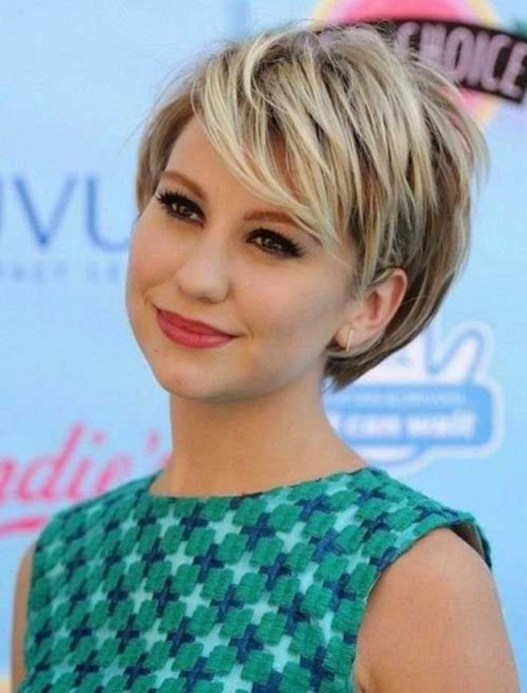Sue

Martin

Lara
John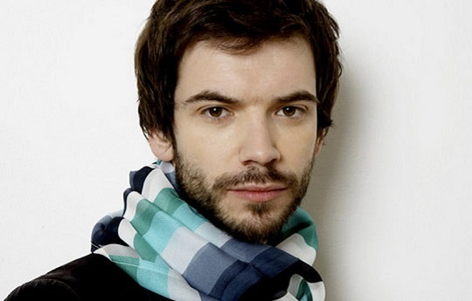

- Sam’s Bill’s granddad/cousin.
- Lara’s John’s sister/wife
- Martin is Laura’s uncle/brother
- Stella is Bill’s cousin/sister
- Sue is Bill’s aunt/mum
- John is Stella’s dad/uncle
- Ann is Bill’s mum/grandma
- Sam is Martin’s dad
2а
2. Complete the pairs
1. Dad - ……………………..................
2. Son - …………………………………
3. Cousin - ……………………………..
4. Brother - …………………………….
5. Uncle - ……………………………….
6. Granddad - …………………………..

3. Read the text. Use the words below to complete the letter.
Husband, cousin, daughter, mum, granddad, brother, dad, ant, grandma, family.

Dear Dana,
I am Rita and I’m 12 years old. I have a big 1) ……………………….. My 2)…………..
Is Lida. She is 45 years old and very friendly and kind. Roman is my 3)……………..
He is 47 and a lovely person. My4) ………………………….. is Nikolay. He is 70 and very funny. He is my father’s father. Elizabeth is my 5)……………………………..
She is 70 and she is a wonderful lady. Gleb is my little 6)……………………………..
He is 7 years old and very clever. My 7) ………………………….. Svetlana, is my father’s sister. Her 8)…………………………………, Andrey is a teacher. Their 9)………………………….Karina is six yeasr old and she is my favorite 10) ………………………………………….. Have you got a family? Please send me a photo!
Irina

2b
Use of English
Present Simple
- Put the verbs into the correct box
Watch/like/tidy/finish/start
Teach/do/study/play/carry
Get/walk/visit/work/use/give
Kiss/talk/try/say/wash

-s | starts,………………………………………………………  …………………………………………………………….
-es | finishes…………………………………………………………………………………………………………………
-ies | tidies, ……………………………………………………..  …………………………………………………………….  ………………………………………………………….....

- Put the verbs in brackets into the correct form.
Nancy 1) gets up (get up) at 7 o’clock in the morning. She 2)…………………(start) her day with a big breakfast. She and her brother 3)…………….. (catch) the bus to school at 7.45. Their journey to school 4) …………………………… (take) half an hour. Lessons 5)………………………….. (start) at 8.30. Nancy 6) ……………………………. (have) lunch at 12:30, then she 7)………………………………………(continue) lessons until 3 o’clock. Nancy 8) ……………………………………. (go) back home at around 3:45. She 9)……………………………(have) a snack, then she 10) …………………. (do) her homework. In the evenings, she 11)………………………………(watch) TV or 12)……………………….. (play) computer games with her brother. They 13)………………………………….(like) action games. Nancy 14)……………………………………..(go) to bed at around 9:30

2b
- Fill in with the appropriate verb from the list: go(x2), get, have (x3), do, meet, watch, play.

- I usually ………………….. breakfast at 7:00.
- Dana…………….. her friends in the afternoon.
- Berik ………….. to school at 9:00.
- We………. your homework in the library.
- Shnar….. to the gym three times a week.
- I………….. computer games on Sundays.
- Aruzhan …………………… lunch at 1:00
- On Wednesdays, Aliya …….. lunch at school.
- My sisters………….. TV in the evening.
- She…………………up early in the morning.

- Complete the sentences so they are true about you.
- I don’t like (like) fish.
- My dad………………..(cook) well.
- Mt mum……………..(go) to work on foot.
- My school lessons…………………. (start) at 8:45.
- I…………………. (catch) the train to school.
- My parents……………………. (play) computer games.
- We………………. (have) dinner at 8:00.

- Write questions correctly.
- I/like/listen to music?
Do I like listen to music?
- your/parents/watch/ football match?
…………………………………………………………
- your friends/get up/early/in the morning?
…………………………………………………………
- she/ wash/the dish/in the afternoon?
…………………………………………………………
- your mum/read/German?
…………………………………………………………
- your cousin/play/a musical instrument?
…………………………………………………………
6. Write questions and answer so they are true about you.
1. When/you/finish/school?
When do you finish school?
I finish school in May.
2. What/you/do/on/Saturdays?
………………………………………………………………..
………………………………………………………………..
3. What/you/have/for/dinner on Sundays?
………………………………………………………………..
………………………………………………………………..
4. How often/you/see/your friends?
………………………………………………………………...
………………………………………………………………...

7. Put the verbs in the Present Simple form.
- One fly_____________ (to fly) , two flies _____________ (to fly).
- One girl _____________ (to cry), four girls _____________ (to cry).
- When a wolf _____________ (to see) the moon, it _____________ (to begin) to howl (выть).
- Wolves and sheep _____________ (to be) never friends.
- Our hens _____________ (to lay [откладывать]) a lot of eggs.
- Boys _____________ (to fight) and_____________ (to shout).
- That boy _____________ (to try) to catch some balls.
- These girls _____________ (to try) to run away from an angry turkey.
- If one goose _____________ (to have) one tooth, how many teeth _____________ (to have) thirteen geese?
8. Write likе or likes.
- I _______ quiz shows.
- He _______ horror films.
- She _______ music programmes.
- My parents _______ the news.
- My friend Nastya _______ cartoons.
- All my friends _______ nature programmes.
- My grandad _______ sports programmes.
9. Give short answers.
- Do you watch the news?
- Does your mum like horror films?
- Do your parents like comedies?
- Does your friend like nature programmes?
- Does your teacher like music programmes?
10. Put the verbs in the present form.
go, like, love, watch, read, like, walk, come, do, watch
My name's Pavel. In the evening I usually (1) ___________ my homework. Then I (2) ___________ TV or video. I (3) ___________ action films! They are super! Then I (4) ___________ my dog. After that I (5) ___________ home, (6) ___________ a book and (7) ___________ to bed. My sister is little. She doesn't (8) ___________ action films. She (9) ___________ cartoons. She (10) ___________ them every day

2c
Reading 1. Read the text

My name is Ilya. I am eight. I go
to school. I am a good pupil
because I always do my
homework and get exсellent
marks. I have got a family. It is
friendly. There are five
members in my family. They are my mum, dad, sister, me and my grandparents. I have got a mum. Her name is Lena. She is thirty-five. My mum is clever and kind. She is a housewife. My mum is good at cooking. Every day she cleans the rooms, washes the dishes and doesn`t let my sister and me fight. I have got a father. His name is Dima. My father is handsome and serious. He is very busy and works a lot. My father is fond of playing computer games. At the weekends we play games together. Also, he helps me with my homework and my mum with housework. He is the best dad in the world!
My elder sister is ten. Her name is Victoria. She looks like my dad. Victoria is strong, clever and talented. She can swim and run. Victoria likes watching cartoons on TV. And the most favourite family’s members are my Grandparents! I love them very much! They are kind and love me very much.
I love my family. I am happy!

2. Answer the questions.
1. Who is the most favourite member of Ilya's family?
2. How many people in the family?
3. Who is the youngest in the family of Ilya?
3a
Vocabulary
Jobs
- a) Look at the pictures. Complete with the name of the job.

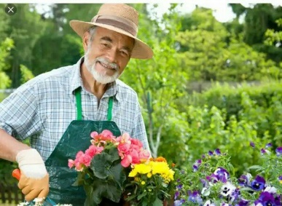

- d……………… 4. g………………..



- a…………….. 5. b………………..
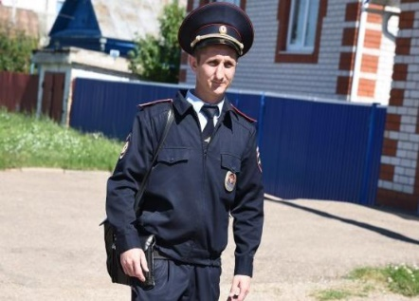
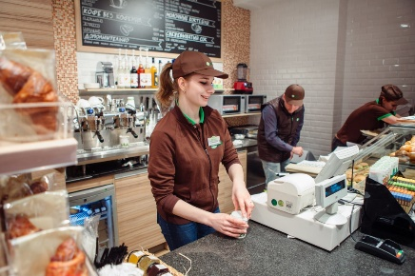

- ……….............. 6. ……………………..
b) A - 1 He looks after sick people.
B - He protects people.
C - She takes money and gives people change.
D - He checks financial records.
E - He grows flowers and trees.
F - He makes bread and cakes.
Job qualities
- a) What job qualities do the pictures show? Label them:
calm, brave, creative, polite, fit, patient.


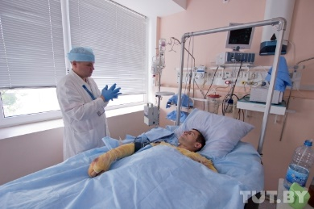

- calm ………… 4. ………………

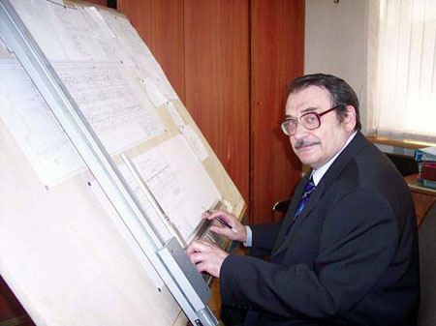
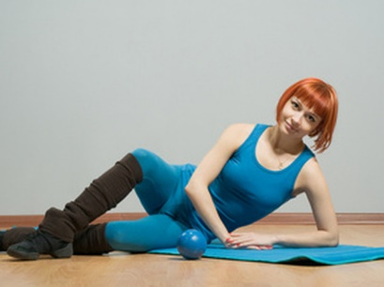

- …………………. 5. …………………


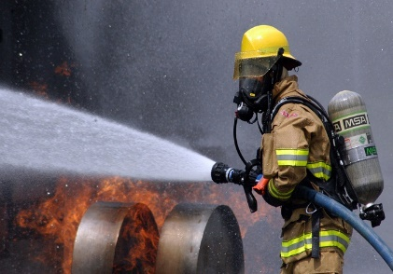

- …………………… 6. …………………….

b) Use the words from Ex. 2 a) to complete the sentences.
1. Doctors need to be calm in an emergency.
2. Artists need to be ……….. because they have to think of new ideas.
3. Cashiers need to be ………….. to customers.
4. Firefighters need to be ……………….. because they have got a dangerous job.
5. Teachers need to be ……………. Because they have to explain things to their students.
6. Aerobics teachers need to be …………….because they do exercise every day.
3b Use of English
Subject and object pronouns
- Write the correct pronounce
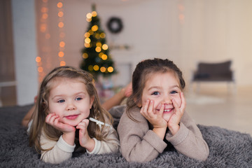
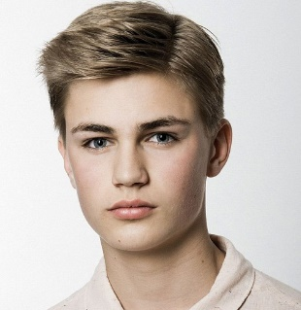

- he………………. 5. ……………………..
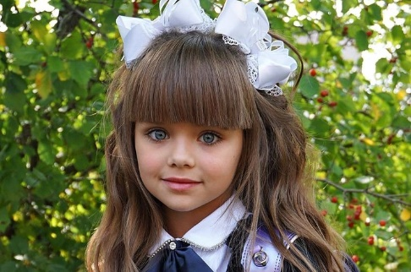
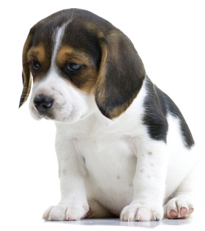

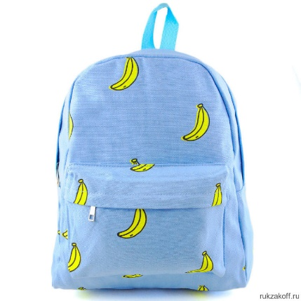
- …………………… 6. ………………………

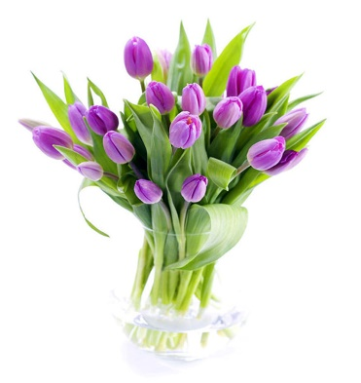


- ……………………… 7. …………………………
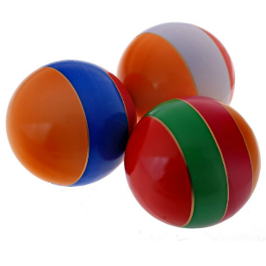

- …………………..... 8. ………………………

3b
- Fill the correct object pronoun.

- Ann is a nice little girl. Let’s to play with her.
- We’ve got a blue papers, but we can’t find ……..
- I can’t catch the trolleybus to the music school. Can your mum drive ……. there?
- Victoria is beautiful. Look at …….
- Danil and Berik are Grade 5. Let’s ask ………. about our homework.

- Choose the right variant
- This is Michael. This is his/her family.
- These are my / his parents.
- This is her / their house.
- This is your / their pet.
- This is her / its ball.

- Complete sentences within the meaning of
- This is my mum. _________ name's Jess.
- These are my sisters. ________ names are Mary and Dina.
- These are my grandma and grandpa. _________ names are Tanya and Bob
- This is my brother. ______ name's Fred.
- This is my sister. _______ name is Nina.
- This is my father. _______ name's John

- Translate from Russian into English
- мой мяч
- ее стул
- наша кухня
- его линейка
- их дом
- наши коробки
- ее кошка
- их тела
- его нос
- моя кровать
- их сад
- его спальня
- наши карандаши
- моя голова
- твой домик на дереве
- моя бабушка
- их ручки
- твой брат
- его собака
- ее комната
- их полки
- наш дедушка
- твой рот
- наши уши
- моя книга
- ее ластик
- твоя рыбка
- его стол
- ее глаза
- твой портфель
- моя игрушка
- его солдатик
- ее кукла
- их плюшевые мишки
- наши рубашки

- Complete the sentences
… hair is dark.
… eyes are blue.
… bodies aren’t fat.
… eyes are green.
… hair is fair.
… mouth is big.
… legs are thin.

- Make the same sentences with the words: our, your, my

- Find six possessive pronouns

M | T
Y |  | H |  |  |  | H
 | O |  | E |  |  | I
 |  | U |  | I | T | S
 | H | E | R |  | R

3с Reading
  - Read the text and answer the questions.

My Future Profession (Journalist)
I decided to be a journalist. I think it is an interesting and useful profession.
I like to watch TV, listen to the radio, read newspapers and magazines. I like everything which connected with mass media.
I have a hobby. My friends and I are publishing a small newspaper once a month in our school. We write articles about school events, life of young people, jokes, draw pictures and caricatures. My favourite school subjects are history and literature.
I like the profession of a journalist. They meet many people. They try to understand what is going on in the world, or the country, or the city and try to explain it to other people.
I think that the work of a journalist is very much like that of historian. A historian studies and tries to explain events of the past and a journalist does the same about the present.
But for me to be a journalist is much more interesting than to be a historian because you deal with real events that are happening right now so you can even influence them.
So journalists can influence the history. That is why I want to be a journalist.
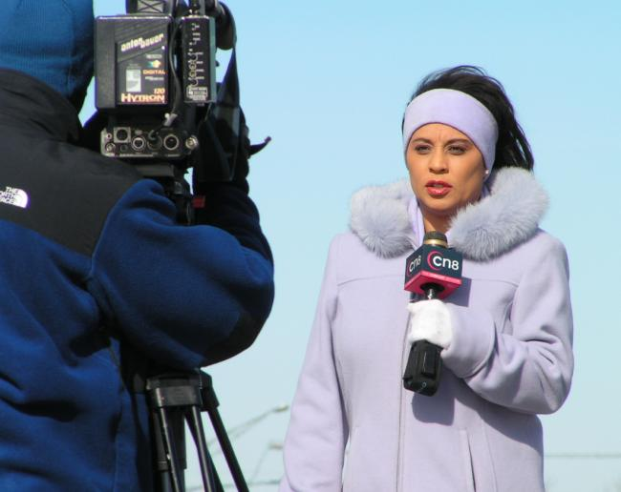
1.What kind of profession does the text say?

2.What is the hobby of the story's author?

3.What are the favorite school subjects from the author?

4.What school subject is journalism in the text associated with?

4a
Vocabulary
Sports
- Look at the pictures and write the names of the sport.
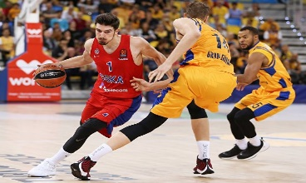
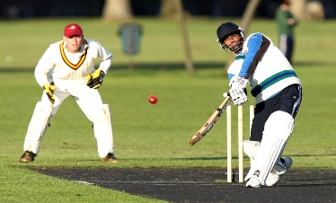


- t………….. 2. c…………… 3. b…………..

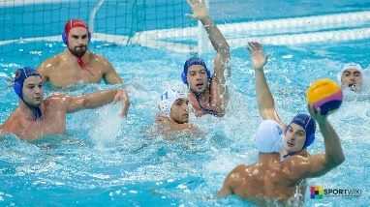
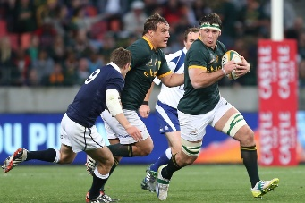

4. r…………… 5. w……p………. 6. f……………….
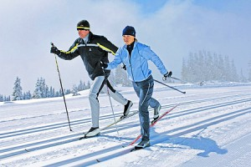
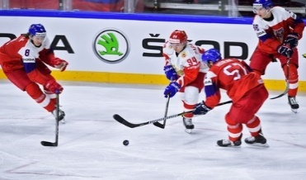
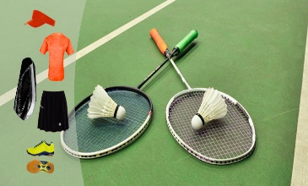
7.b…………….. 8. h……………… 9.i………………
2. Look at the table and complete the sentences with the correct adverb of frequency.
never | *
sometimes | **
often | ***
usually | ****
always | *****

- Alma ……………plays cricket with her friends after lessons.**
- I……………. play basketball.*
- She ……………..plays water polo at the weekend. **
- He ……….. has a football lesson on Fridays.*****
- He…………………plays badminton with his sister on Friday mornings. ****

4a
3.Complete the sentences. Use: do, play or go.

- They often………….. karate on a Thursday.
- Does he know how to ………….. rugby?
- Ben and Bill ……………. gymnastics.
- Let’s ………………..cycling at the weekend.
- Can you …………….water polo?
- Where can I learn to …………. judo?

4. a) Match the words to from phrases
1. choose a. medal
2. win b. part
3. take c. competitions
4. competitive d. games
5. school e. from
6. silver f. subjects

b) Use phrases to complete sentences.
1. They are good team. They always…………………..
2. Didar has got a ………………………. For judo
3. In our PE lessons, we can ……………………… basketball or tennis.
4. The students ………………….. in competitions around the world.
5. Ainura’s favourite …………………………are English amd History.
6. In ………………….like football and basketball, teams want to always win.

5.Write the letter about your favourite sport to your friend.

6.a) Label the picture with the names of the equipment.
/racquet/goggles/hoop/helmet/poles/bat/ball/skis
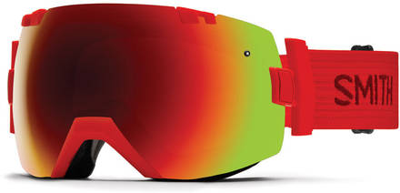
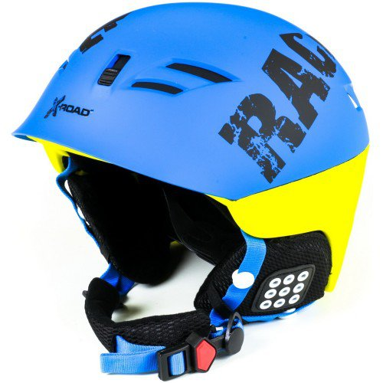
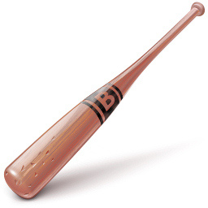

1………………. 2………………… 3……………………..
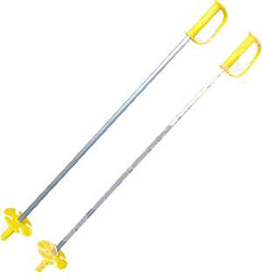
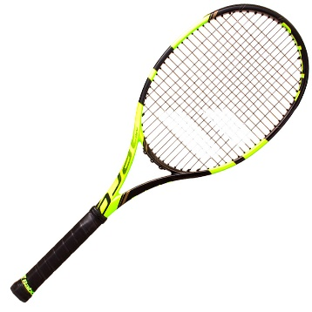
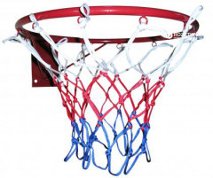

4. ………………… 5………………….. 6…………………..
b) What do you need to play tennis? go skiing? play cricket?
Write sentences.
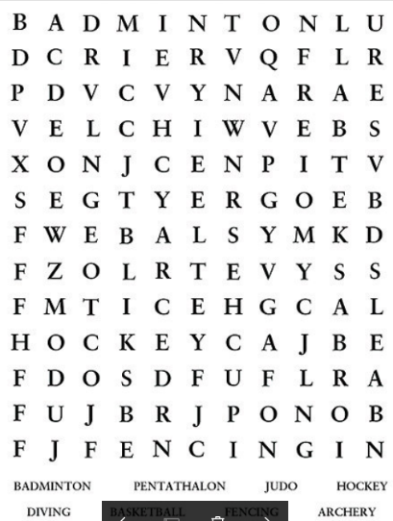
We need …………………….... 5. Find the words
to play………………………….
…………………………………
………………………………...
2………………………………
…………………………………
…………………………………
3………………………………..
…………………………………
………………………………….

4b Use of English
a/an/some/any
- Complete the sentences. Use a/an/some or any
- There’s…………….. football match at the school tonight. Let’s go.
- Diana has got ……………….important judo competition today.
- I’ve got ………………….helmet and……………….. skis, but I haven’t got ………………..goggles.
- We’ve got a lot of cricket balls, but we need…………….new bats.
- Are there………………..tennis racquets in the school sports cupboard?

- Complete the description. Use a/an, some or any
Alexander Vinokurov is 1)……….. amazing cyclist. He rides for 2)……………… team called Ribox. He has got a 3)……………….
Special bike and he always wears 4)…………….. helmet, 5)………….. glasses and 6) ………………… gloves when he goes cycling. Alexander wins a lot of races, but he hasn’t got 7)…………… medals from the Olympics yet.

much/many-a lot of
2.Choose the correct item.
- It’s important to drink much/a lot of water when you play sport.
- Dias doesn’t watch many/much sport games on TV.
- There are a lot of/much athletes in my city.
- Not many/much people go bowling these days.
- The tickets for the game cost many/a lot of money.

- Insert much or many.
- You can see ________ cars near the airport
- You mustn't eat so ________ bananas
- You mustn't drink so _______________

4b Use of English
- He hasn't met ________ people there.
- He didn't ask ________
- He bought _______ furniture for his new flat.
- This work won't take ______ time.
- Have we got _______ apples for the children?
- I don't like _______ salt in the salad
- My little sister speaks _________ that's why we call her «a chatter box».

4.Use “much” or “many” to express “How much ...?”.
- How … days?
- How … sugar?
- How … cigarettes?
- How … work?
- How … petrol?
- How … children?
- How … theatres?
- How … juice?

5. Put "a lot of" (many) in the right place in the sentence. Translate.
- We met interesting people at the party.
- I ate fish for lunch.
- She bought nice shoes for the next summer.
- They have problems in their business.
- There is water in the bath.

6. Complete a lot/a lot of/much/many.
1. Do you drink ___ tea?
2. I like reading. I've got _____ books.
3. There isn't _____milk in the fridge.
4. It costs _____money to travel round the world.
5. Please be quick! I haven't got ________ time.
6. How ________ foreign languages can you speak?

4c Reading 1. Read the text.

I like sport. It plays a great role in my activities. Most of all I like to play basketball. I am the best player and often take part in different sport competitions. Sometimes we win them but sometimes we lose. Basketball is a team game. It is played in any season because you play this game is indoors game. It is played in a gym. But sometimes you can see streetball - basketball in an open air. There are two baskets in this exciting game and only one orange ball. Players must throw the ball to the basket and get to it to score a goal. There are two teams with only five players. Many people keen in sport because it makes us more healthy and help us to be fit. During you play any sport game you are active and it helps you to burn many calories. Basketball is an active game. It makes people be strong, healthy and energetic. It is a game for everybody even for disabled people. To my mind any sport is risky and dangerous. Basketball is risky too because every minute you can break your arm or leg or get another problem with your health. I like playing basketball most of all. And I am a basketball fan too.

2.Underline the right variant.
1. Basketball is risky/safe.
2. Basketball is an active/passive game.
3. Basketball is a team/single player game.
4. There are two/three teams with only five players.
5. There are two baskets in this exciting game and only one/two orange ball.
6. Players must throw/ kick the ball to the basket.

5a
Vocabulary
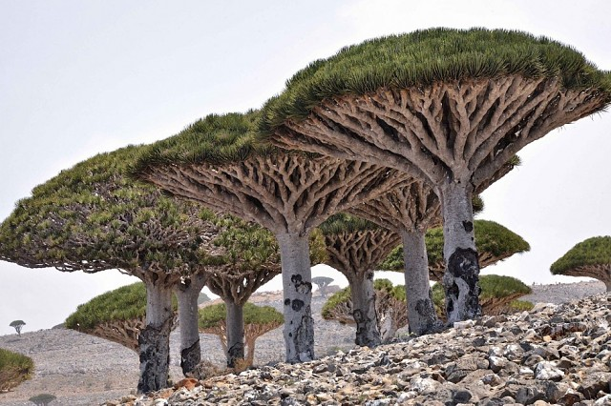
Unusual plants
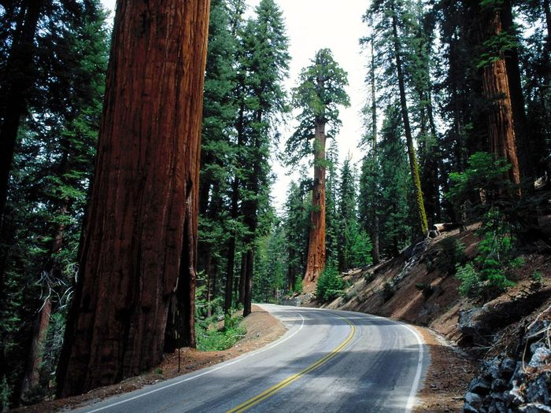

- Sequoia tree 3. Dracaena-cinnabar
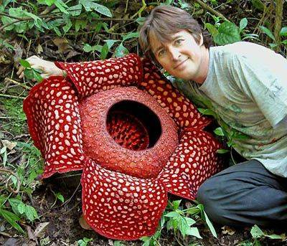
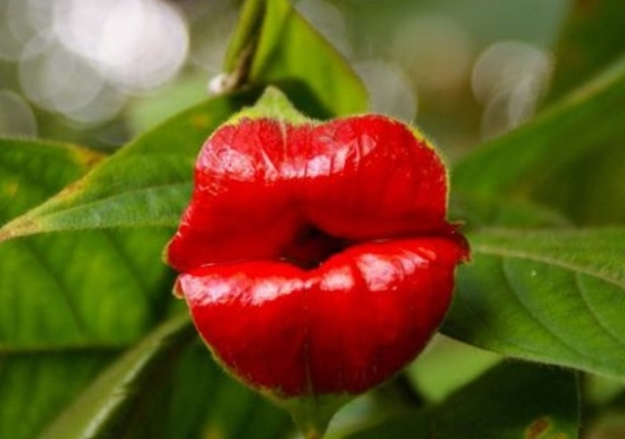

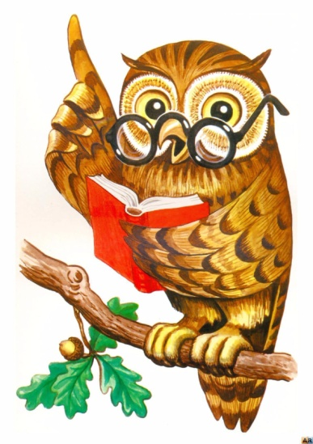
- Psychothrias flower 4. Rafflesia flower

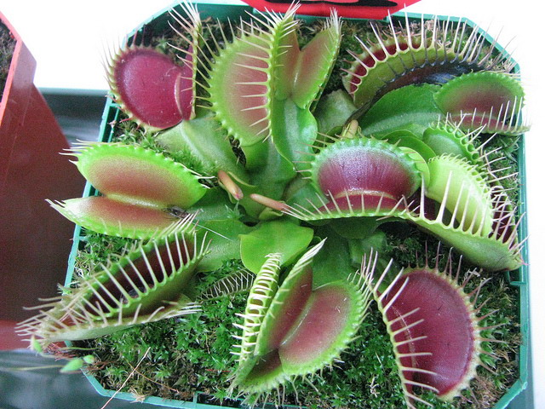

5. Dionea

5a
- Complete the sentences with the appropriate words:
predatory, lips, tall, wide, mushroom.

- Sequoia tree is very……………………..
- Dracaena-cinnabar is like to……………………………
- Unusual flower psychotrias very much like…………….
- Rafflesia flower is spotty and ………………………
- Dionea houseplant is considered a……………. plant.

- Thinking owl.

Dionea

Rafflesia flower

5b Use of English
Comparative/Superlative adjectives.

- Write sentences in superlative form.
- Sequoia tree is (tall)………………………………
- Dracaena-cinnabar is (wide)……………………...
- Psychothrias flower is (bright)…………………...
- Rafflesia flower is (fat)…………………………..
- Dionea flower is (sharp)………………………….

- Use the adjectives below to describe the plants in the sentences.
wide sharp tall bright fat

- ............... Sequoia tree is taller than usual trees.
- …………. Rafflesia flower is bigger than usual flowers.
- …………… Dracaena-cinnabar is wider than other trees.
- Psychothrias flower is………………than usual flowers.
- Dionea flower is …………than rose thorns.
- Complete the chart.
Adjective | Comparative | Superlative
wide | wider | the widest
tall
bright
sharp
fat
big

5c Reading 1. Read the texts.

Sequoia is the tallest conifer on earth. It grows in the only place on our planet - in the Sequoia and Redwood national parks in California, USA.
Sequoia was named after the leader of the Indian tribe Cherokee Sequoias, who first invented the alphabet for his tribe. By the look of redwoods resemble our pine, only enlarged several times. Their trunks reach to the sky to a height comparable to the 50-storey skyscrapers, above 100 meters. Sometimes sequoias live up to four thousand years. This is due to the strength of their wood and the pungent smell of resin, which scares the wood beetles. Sequoia has another protective agent — a thick bark that absorbs moisture well. It saves the giant from fires. Imagine, the bark of the redwoods is not burning! The fire charms only the outer layer of the bark.

2.Circle the right variant
1. Sequoia was named after the leader/writer.
2. Their trunks reach/don’t reach to the sky.
3. Sometimes sequoias live up to one/four thousand years.
4. It saves the giant from fires/water.

5c
1. Read the texts.
The cinnabar dracaena is a tree with a thick crown, shaped like a giant mushroom cap or an umbrella. His foliage is green, the trunk and branches are grayish-brown, also seems to be an ordinary shade. There are 6 species of dracaena in the world in the form of a tree And the secret of the “red” name lies in the blood-red resinous juice, which is distinguished by our heroine, Dracaena cinnabari (lat.), That is, the dracaena is cinnamon-red. In its natural environment, it grows on the island of Socotra, which is located in the northwestern part of the Indian Ocean.

- True or False
- The cinnabar dracaena is a tree _____________
- His foliage is brown _______________
- There are 6 species of dracaena in the world__________
- it grows on the island of Socotra_______________
- It is located in the southwestern part of the Indian Ocean
___________

5c 4. Read the text.
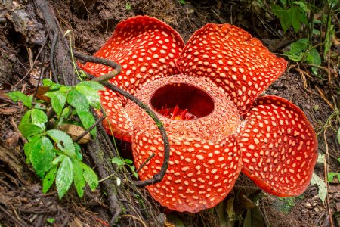
In the forests of the Indonesian islands of Kalimantan and Sumatra, and in Malaysia and the Philippine Islands, a unique plant, Rafflesia Arnoldi, grows. Rafflesia has the largest flower in the whole globe - its diameter reaches 1 meter, and its weight is 10 or more kilograms. By the way, rafflesia has neither its own roots, nor leaves, nor a stem, and feeds only on the sap of tropical vines. On their roots, it is parasitic.

5.Read the text.
Psihotriya is a rather unusual plant, in whose existence not everyone will believe. It resembles the interesting shape of the lips, which would envy not one girl. This amazing plant lives in America - Central and South. This flower attracts a lot of insects, including many hummingbirds and butterflies.

5c
6.Read the text.
Predator plants are rather rare specimens, as it is rather difficult to grow them in the conditions of the house conditions because of the constant amount of: flies, mosquitoes. Latin name Dionea translated as "mousetrap".

7.Answer the questions.

1. What is the biggest flower on earth?
2. What resembles an unusual plant Psychotheria?
3. Why do indoor Dionea flower is called predatory?
4. What is the biggest weight of rafflesia flower?

8. Circle the right variant.

1. Rafflesia has the largest/smallest flower in the whole globe.
2. This flower attracts/ repels a lot of insects, including many hummingbirds and butterflies.
3. Dionea translated into Latin as "mousetrap"/"flycatcher".
4. Psihotriya lives in America - Central and South/North.
5. Predator plants difficult/easy to grow.
6. Rafflesia has neither its own roots/ petals.
7. These plants really unusual/usual.

6a
Vocabulary
Transport
- Use the adjectives to complete sentences.
/comfortable-uncomfortable/, /fast-slow/,
/expensive-cheap/, /safe-dangerous/
/exciting-boring/, /relaxing-tiring/

- I enjoy travelling by car. It’s fast.
- I don’t enjoy………………………………
- I’d like to travel………………………….
- I think travelling by ………………………………..
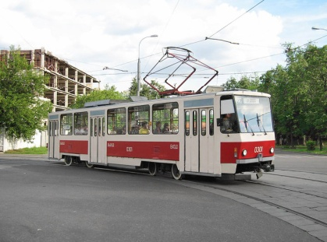
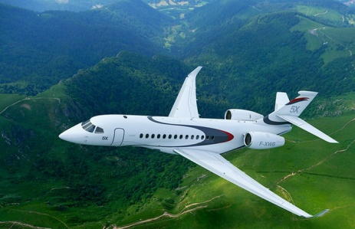
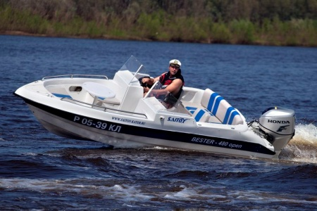
1.

- motorboat 2. airplane 3. tram
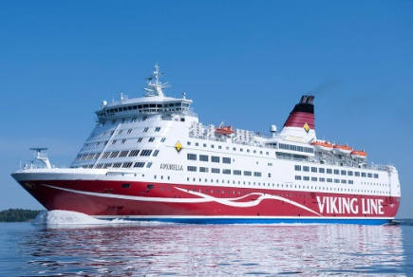

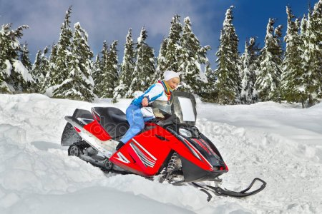

- snowmobile 5. lorry 6. ferry
Note:
by+ train, bus, car etc
He comes by train.

6b Use of English
Relative pronouns.
- Choose the correct pronounce.

- The bike that/who is across the road belongs to Aibek.
- The man which/who sits by me in the class is very polite.
- That’s the girl whose/which father drives a taxi.
- That’s the shop which/who sells postcards.

- Join the sentences. Use who, which or whose.
- There is the cycle path. T leads to the town centre.
There is the cycle path which leads to the town centre.
- Nurlan is the mechanic. He fixed my car.
………………………………………………………
……………………………………………………….
- This is the train. It goes to the railway station.
………………………………………………………..
………………………………………………………...
- Berik is the man. His car is parked outside my house.
………………………………………………………..
……………………………………………………….

- Replace the adjectives in bold with their opposites. Use: cheap, dangerous, comfortable, relaxing, slow.
1.The new trains are very uncomfortable and clean.
……………………………………………………………
- You can book expensive tickets online.
..............................................................................................
- Travelling in an airplane is very tiring.
……………………………………………………………..

6b Use of English
- The buses are very fast in the morning.
……………………………………………………………..
- It can be safe to ride on a snowmobile.
………………………………………………………………

- Match the pictures to the words.

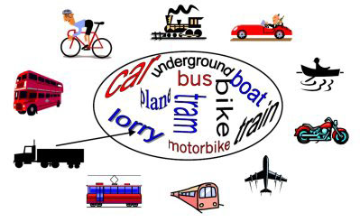
- Make the crossword.

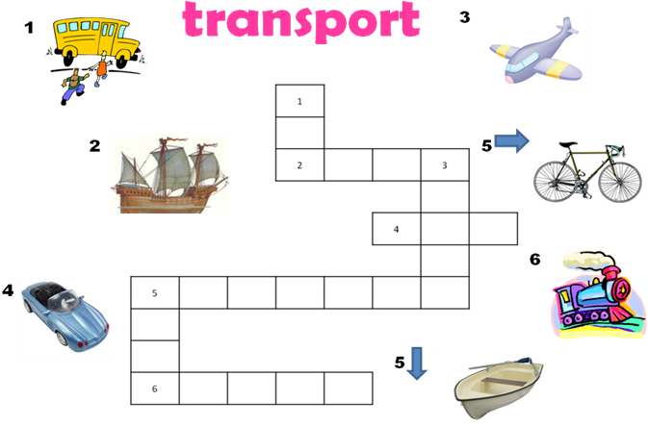

6c
Reading 1. Read the text.

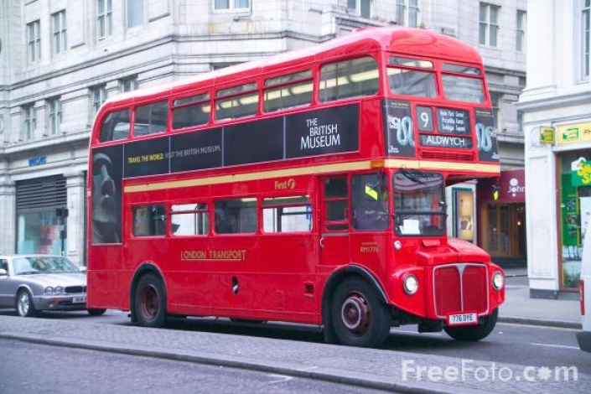
Transport in London
London is a huge metropolitan area that is why public transport is vitally important for the city dwellers as well as tourists, for whom it might be quite confusing to get about London. Unlike in our public transport, British transport system is reliable and quite cheap. However, due to the increase of car ownership, London traffic has become 3 times as heavy as it used to be and the length of the traffic jams increased dramatically. As a result, the problem of fatal car accidents appeared.
Apart from taxies, there are 2 main methods of transport in London: the Underground and the buses. Buses are best for sightseeing, especially double-decker buses. However, they are rather slow, especially during the rush hour. On the traditional double-decker there were no doors and passengers leaped up and off the bus and conductor was moving about and collecting fares from the passengers. However, nowadays fares are given directly to the driver or to the machine. Moreover, London transport has recently introduced single-decker buses which are called "Red Arrows".

- Circle the right variant.
- There are 2 main methods of transport in London: the Underground and the buses/cars.
- Buses are best for sightseeing, especially double-decker buses/red buses.

Reading for pleasure
- Read the text.

The Earth
We live on the Earth. It is very, very big. There is a lot of water on the Earth. It is in rivers, lakes, seas and oceans. There are a lot of forests and fields, hills and mountains on it. The Earth is full of wonders. Different animals live on the Earth. Different plants grow on it. The Earth is beautiful. There are large countries and small countries. There are warm countries and cold countries. There are some countries where there are four seasons in a year and some countries where there are only two. When it is day in one country it is night in another country.
When the sun shines it is day, when the sun does not shine it is night. You can see the moon and the stars in the sky at night.
People live in diffe rent countries. They speak different languages. Our country is Kazakhstan. Kazakhstan is the largest country in the world. Our country is so large that when it is morning in the east, it is evening in the west. When it is winter in the north it is summer in the south. There are a lot of long rivers, beautiful lakes, large forests and fields and high mountains in Kazakhstan. People who live in Kazakhstan speak more than one hundred different languages but they can speak Kazakh too.

2. Answer the questions.
1.Where do people live?
2.Is the Earth big or small?
3.What is there on the Earth?
4. Where is there water on the Earth?
5.The Earth is beautiful, isn't it?
6.Why do we say that the Earth is full of wonders?
7.Why do people speak different languages.?

Reading for pleasure
Past Simple
- Read the text.

Uncle and Auntie Pat (Chapter One)

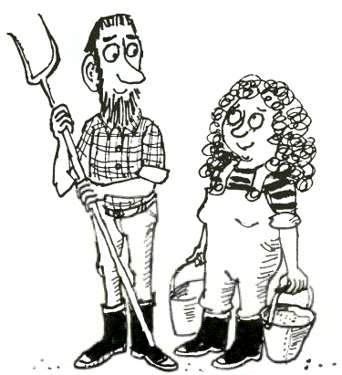
This is a story about my uncle and aunt. And guess what? They’re both called Pat! Last year, Mum and Dad agreed I’d stay with Uncle-and-Auntie Pat during the summer holidays.

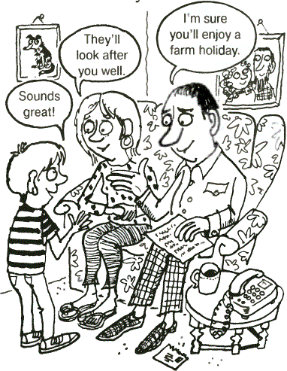
Uncle-and-Auntie Pat live at Wishing Well Farm, way out of town. It isn’t an easy place to find. Dad must have driven straight past without realising.
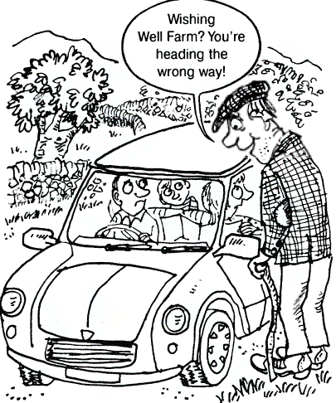
Before long, we were completely lost, and had to ask the way.
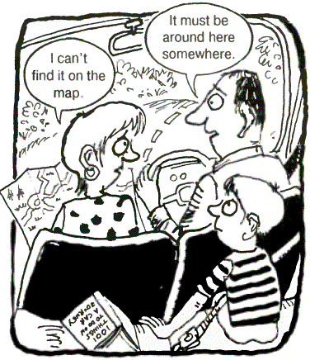

We followed the man’s long list of directions. We drove through one village…
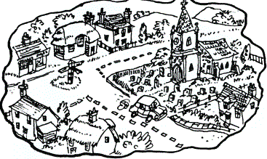
…and then another…
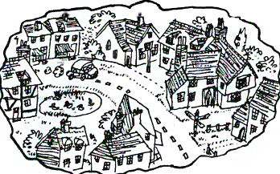
…over two bridges…
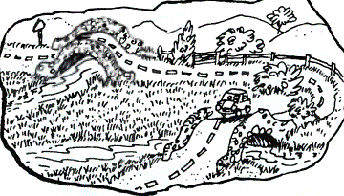
…past a huge out-of-town superstore…
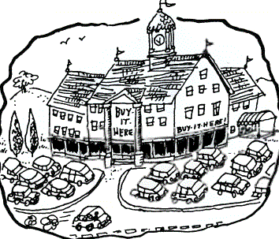
…and down a twisty lane.
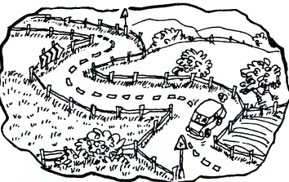
Finally we spotted a half-hidden broken sign.
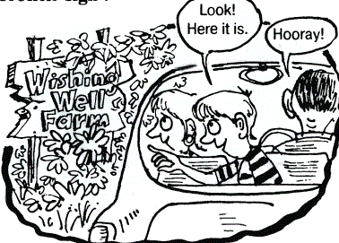
We drove up a muddy track, and found Uncle-and-Auntie Pat feeding the animals.
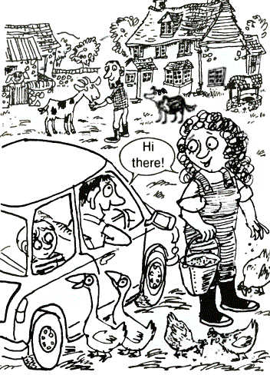
"You managed to find us, then," said Uncle Pat.
"Only just!" muttered Dad.
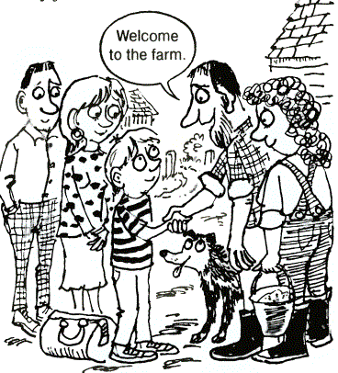
Everyone greeted each other, and then just as quickly, Mum and Dad were saying their goodbyes.
I stood and waved as their car disappeared down the dirt track.
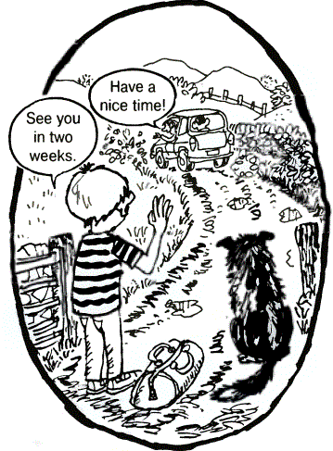

- Write out the regular past tense verbs that appeared in the text.
………………………………………………………………………………………………………………………………………………………………………………………………………………………………………………………………………………………………………………..

Uncle and Auntie Pat (Chapter Two)
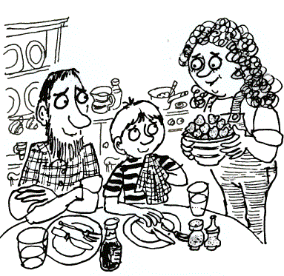
Uncle-and-Auntie Pat soon made me feel at home. They cooked me a slap-up15 meal — heaps16 of scrambled egg, jacket potatoes and fresh vegetables followed by strawberries and cream.
Then they told me about Wishing Well Farm.

Use of English 1b
There is/There are
 | Singular | Plural
Affirmative | There is a carpet  There’s a carpet | There are carpets
Negative | There isn’t a carpet | There aren’t carpets
Interrogative | Is there a carpet? | Are there any carpets?

- We use there is before nouns in the singular. There is a computer on the table. There’s a book on the desk.
(NOT: There are a book, a ruler and an eraser on the desk)
- We use there are before nouns in the plural. There are hasn’t got a short form
(NOT: There’re three books on my desk)

Short  answers | Yes, there is.  No, there isn’t | Yes, there are.  No, there aren’t

- In short answers we use Yes, there is/are or No, there isn’t/aren’t. Don’t repeat the whole question. Is there a lamp on the table? Yes, there is.
(NOT: Yes, there is a lamp on the table)

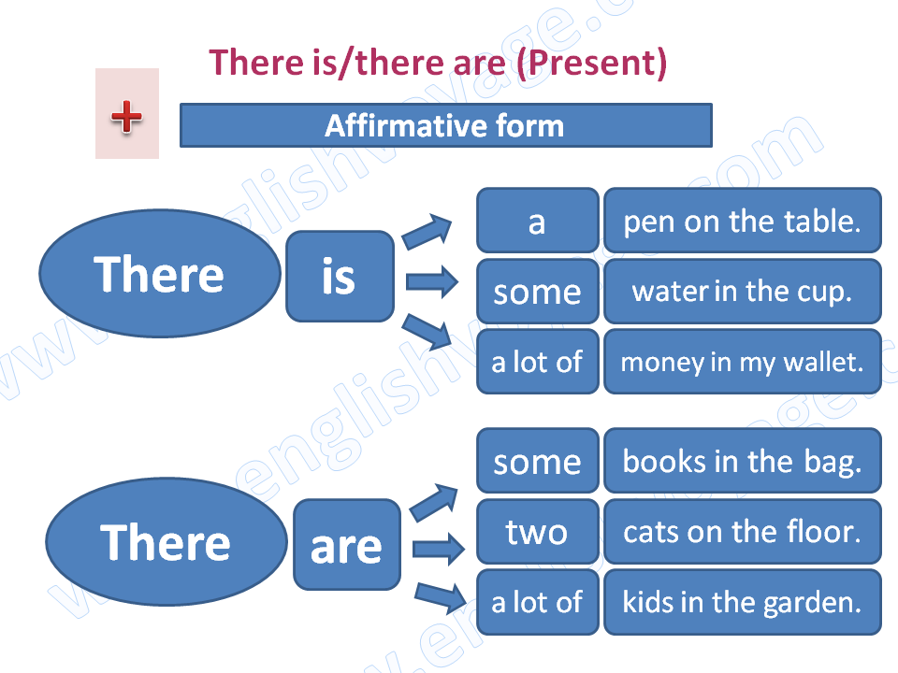

Use of English 1b
a/an-some-any

 | COUNTABLE NOUNS |  | UNCOUNTABLE  NOUNS
 | Singular | Plural | UNCOUNTABLE  NOUNS
Affirmative | There is a sofa | There are some sofas | There is some milk
Negative | There isn’t a sofa | There aren’t any sofas | There isn’t any milk
Interrogative | Is there a sofa? | Are there any sofas? | Is there any milk?

- A/an is used in affirmative, negative and interrogative sentences with countable nouns in the singular. There is a sofa. There isn’t an armchair. Is there a lamp?
- Some is used in affirmative sentences with plural countable nouns and with uncountable nouns.
We need some carrots and some butter.
- Any is used in negative and interrogative sentences with both countable nouns in the plural, and uncountable nouns.
There aren’t any oranges. Is there any coffee?

NOTE: We can use some in interrogative sentences to make offers or requests.

Would you like some pears? (offer)
Can I have some chips? (request)

Use of English 2b
Prepositions of place
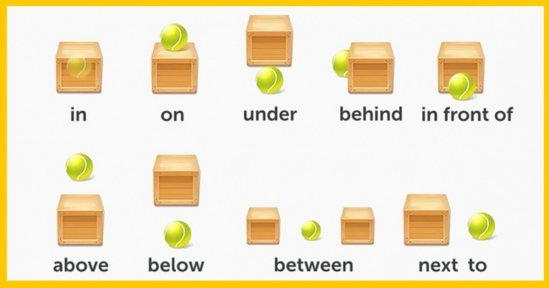
- We use prepositions of place to say where somebody or something is.
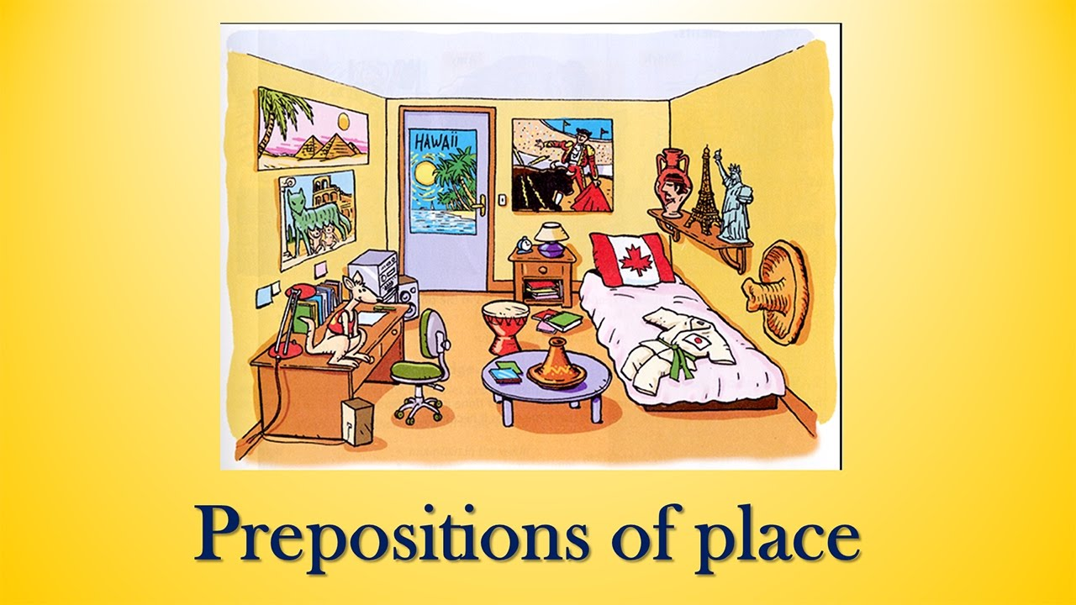

There are pictures on the wall
………………………………………………………………..

Use of English 2b
Present Simple
AFFIRMATIVE
I/you sleep | we/you/they sleep
he/she/it sleeps
- We form the affirmative of the present simple with the subject pronoun (I/you/he/she/it/we/you/they) or noun and the base form of the verb (speak, walk etc.)
- We use the present simple to describe permanent states, repeated actions, habits, daily routines and timetables.

I live in Kazakhstan. (permanent state)
She plays volleyball every day. (repeated action)
He walks to work.(habit)
They cook lunch at 12 o’clock.(daily routine)
The movie starts at 7 o clock.(timetable)
INTERROGATIVE
Do I/you run? | Do we/you/they dance?
Does he/she/it run?

SHORT ANSWERS
Yes, I/you do.  Yes, he/she/it does.  Yes, we/you/they do | No, I/you don’t  No, he/she/it doesn’t  No, we/you/they don’t

- We form the third person singular in the interrogative with does+subject+main verb (without-s) Does she like fish?
- We form all the other persons with do+subject+main verb. Do they like basketball?

Use of English 2b
Present Simple

NEGATIVE
Long form | Short form
I/you do not sing  he/she/it does not sing  we/you/they do not sing | I/you don’t sing  he/she/it doesn’t sing  we/you/they don’t sing

- We form the negative of present simple in the third person singular with subject (personal pronouns, nouns or names)+does not/doesn’t+main verb (without-s)
She doesn’t like tennis.
- We form all the other persons in the negative with subject+do not/don’t+main verb.
I don’t like basketball.

Spelling (3rd person singular)
- We form the third person singular (he/she/it) by adding-s to the end of most verbs.
I like-he likes, I eat-he eats.
- We add-es to verb that end in – ss,-sh,-ch,-x, or-o
I miss –he misses, I brush-he brushes, I teach-he teaches,
I fix-he fixes, I do-he does
- Verbs ending in a consonant+-y, drop the –y and take –ies.
I study – he studies, I cry – he cries
- Verbs ending in a vowel+ -y, take- s
I play – he plays, I stay – he stays

Use of English 3b
Subject and pronouns
- We use subject pronouns before verbs instead of nouns or names.
Peter is a doctor. He is from England.

SUBJECT PRONOUNS
Singular | Plural
I  you  he/she/it | we  you  they
I – always with a capital letter
you – in the singular and plural
he – for a man or a boy
she – for a woman or a girl
it – for an animal or a thing
we – for people
they – for people, animals or things

- We use object pronouns after verbs.
Peter is a doctor. Look at him!

OBJECT PRONOUNS
Singular | Plural
me  you  him/her/it | us  you  them

Children play football. Look at them.

Use of English 4b
Much/many/a lot of
- We use a lot of in affirmative sentences with either countable nouns in the plural or uncountable nouns. We omit of when a lot is not followed by a noun.

She has got a lot of pictures.
A: Is there any oil?
B: Yes, there is a lot.

- We use much or many in the negative and interrogative.
We use much with uncountable nouns and many with countable nouns in the plural.

I don’t drink much water.
Is there much butter in the fridge?
I haven’t got many pencils.
Have you got many books.

- We use how much and how many in questions. We use how much with uncountable nouns and how many with countable nouns in the plural.

How much tea do you drink every day?
How many biscuits are there in the packet?

- We use a few with plural countable nouns.
- We use a little with uncountable nouns.

Use of English 5b
Comparative/Superlative adjectives
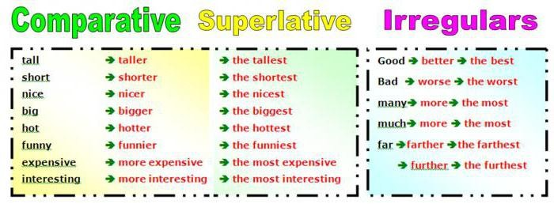
- We use the comparative to compare one person, animal or thing with another. We normaly use than with comparative adjectives. Rose is taller than Mary.
- We use the superlative to compare one person, animal or thing, etc., with the entire group. He’s the tallest in his class. We use the…of/in with the superlative. We use in with the superlative when we talk about places. He’s the tallest of all. The Nile is the longest river in the world.

Form
- With adjectives of one or two syllables, we form the comparative by adding-er, and the superlative by adding –est. big-bigger-biggest.
- With adjectives of more than two syllables, we form the comparative with more and the superlative with

Use of English 5b

the most. expensive-more expensive-the most expensive
- With some adjectives of two syllables, like clever, narrow, gentle, friendly, etc., we form the comparative and superlative with –er/-est or with more/most.

friendly-friendlier-friendliest or friendly-more friendly – the most friendly.

Spelling
- Adjectives of one syllable that end in-e, add –r in the comparative and –st in the superlative.
Simple-simpler-simplest

- Adjectives with one syllables that end in vowel+consonant, double the final consonant and add – er/-est. fat-fatter-fattest

- Adjectives of two syllables that end in-ly or –y, change y to I and add –er/-est. happy-happier-happiest.

Note the examples:
Very+adjective/adverb-It’s very dark in here.
Much+comparative-It’s much colder today than yesterday.

Use of English 6b

In English, the following relative pronouns exist: who (who), that (what, which), which (who), whom (to whom, to whom), whose (who) and whoever / whomever (whoever / whoever). In general, relative pronouns are needed in order to introduce relative clauses.

Usually this kind of subordinate clauses refers to a word, phrase or meaning of a main clause that acts as an antecedent (a noun or its equivalent, to which the subsequent pronoun refers).

In the following examples, the relative pronouns of whom and that affect the subject, which is an antecedent

